**The New Face of American Unemployment**

**As the U.S. labor force crests again, a new complex of problems locks many Americans out of the workplace.**

By [Jeanna Smialek](https://www.twitter.com/jeannasmialek) and [Patricia Laya](https://www.twitter.com/PattyLaya)

Even at so-called full employment, some 20 million Americans are left behind.

They’re looking for work, out of the labor force but unhappy about it, or report working part-time when they’d prefer more hours, according to data released last week. Their plight comes even as the U.S. flirts with what economists consider the maximum level of employment for the first time since before the recession, having added 15.8 million jobs since the start of 2010. While some of America’s jobless are simply between gigs, those persistently stuck out of work are called the structurally unemployed.

President Donald Trump said wrongly last month that 96 million people are looking for work, having included Americans who are still in school, retired, or just uninterested. Yet his words resonated in a country where economic insecurity is distributed unequally and cruelly—far deeper in Mingo, W. Va., than in midtown Manhattan.

Because of [where the structurally unemployed live](https://www.bloomberg.com/features/2017-new-unemployment/#West-Virginia), [what they’ve done](https://www.bloomberg.com/features/2017-new-unemployment/#Florida), or [the skills they lack](https://www.bloomberg.com/features/2017-new-unemployment/#New-York), employers [can’t](https://www.bloomberg.com/features/2017-new-unemployment/#Pennsylvania) or [won’t](https://www.bloomberg.com/features/2017-new-unemployment/#California) hire them. The problems that keep today's jobless stuck on the sidelines are different than those of past recoveries: a complex web of often interrelated issues from disability and drug use to criminal records.

Behind the statistics are people with 20 million unique stories. Here are five.

**Fighting To Get Out of Mingo, W. Va.**

by Jeanna Smialek

Tyler Moore’s late-December drive to Louisville, Ky., was one of desperation. He was headed four hours west on Interstate 64 to interview for a job. Even if he landed the position, filling his gas tank had left him with $8 to his name. He would have to sleep at a friend’s place until he could earn enough to pay rent.

The 23-year-old had run out of options. He’d applied for dozens of jobs within an hour and a half of his hometown of Lovely, once a coal-mining stronghold. Instead of opportunities, he had found waiting lists.

“Minimum-wage jobs, fast-food restaurants, Wal-Mart, anything like that, a lot of them has already been took,” he says in an Appalachian drawl, explaining that the backlog just to interview was as long as a year. “There are no jobs.”

Moore’s story paints an extreme picture of how an economic environment can create a vicious circle of joblessness. While he is an imperfect job candidate, his flaws were molded by his upbringing in Martin County, Ky. and neighboring Mingo County, W. Va.

His problems started in earnest in 2014. He had been living on his own for several years, having moved out at 18 after dropping out of high school, obtaining his GED, and going to work in security at a coal company. Moore is gay in an intensely conservative region, and he said he left school because of bullying.

Moore lost his job in late 2013 after smoking marijuana and failing a drug test. Though he found temporary work as a remote customer service representative, he lost that one when his mother died of a drug overdose in 2014 and he had to plan her funeral.

Deeply depressed and unemployed, he moved into an old Airstream camper propped on cinder blocks behind his father’s house, at the entrance to the litter-strewn trailer park that the older man owns in the misty hills of Lovely. There, surrounded by long-unemployed neighbors and rampant drug use, Moore began to abuse his medical prescriptions. “I guess I used it as my crutch, in a way,” he says.

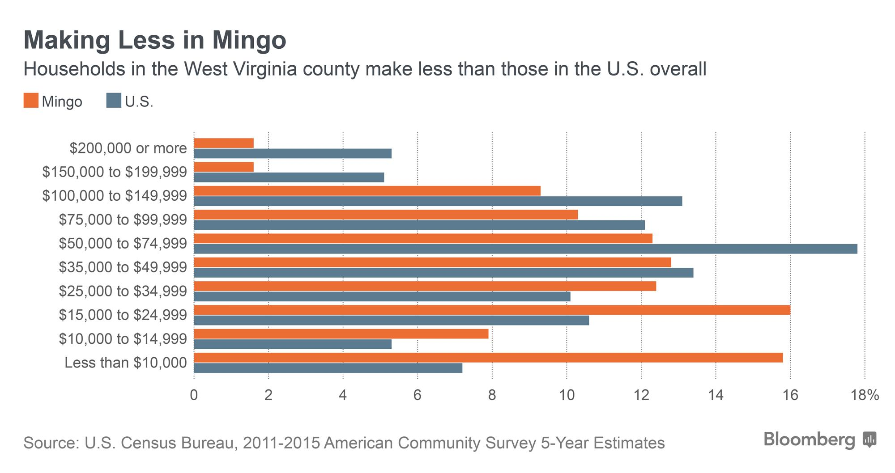

Moore began getting in fights while drugged and was arrested twice. When he landed in jail for several months, he realized things needed to change. He graduated from a rehabilitation program in September, one year, one month, and 15 days after that last altercation. Since then, he’s deepened his friendship with Sister Therese Carew, a Catholic nun who ministers to the region, and dedicated his time to job seeking.

Opportunities are few. Coal mines have been closing, and they’ve taken most other businesses with them.

To employers outside the area, the fact that Moore is neatly groomed, soft-spoken, and polite can’t mask his history. What’s more, he’s the first to admit that the math skills he learned in the local public schools—where only eight in 10 students graduate—aren’t up to par, and his speaking patterns are colored by regional grammar.

His situation is difficult, but Moore has found a reason to hope.

He didn’t get the job for which he made that 240-mile (386-kilometer) drive, but he dropped in to his old rehab center on the way home. When he explained his predicament, the director of operations told him that he could come back until he gets on his feet. The group has found a job for him in plastics manufacturing that could turn full-time after a 30-day probation period. The position is enabling him to pay $100 a week in rent. It’s a chance to build an employment record as he fights to have his record expunged.

Still, moving out requires a tough tradeoff: Moore would have preferred to stay close to home, because his family is still in Kentucky and his father is in his seventies. And the job probably isn’t a pathway to wealth and ease. But what Moore wants most is mere self-sufficiency.

“A simple lifestyle, but being able to have work: I ain’t got to have nothing exquisite,” he says.

**Branded as Untouchable by a Felony Rap**

By Patricia Laya

These days, David Wolf doesn’t allow himself to get excited by the news of a job offer. Most get rescinded within days. It’s happened at least a hundred times, he said.

In 2012, Wolf was convicted of faking a name and Social Security number to get prescription painkillers. Now the 40-year-old father of three and former Marine, who has an associate’s degree from St. Petersburg College, has struggled to find employment. He's received so many retracted offers that he’s lost count.

“I get more interviews that I can shake my stick at, but again, it always comes back around to the denominator of being a felon,” Wolf says from his small, one-level ranch house in a Tampa, Fla., suburb, where religious imagery and family photos decorate his walls. “For many, many years, I pretty much got whatever job I wanted. I was able to do anything I felt like doing. It’s really been a humbling experience.”

Wolf, whose chaotic life before he got clean included several domestic battery and drug-related charges, is one of the more than a half-million people who are released from U.S. federal and state prison every year. The influx occurs as the nation comes out of a decades-long war on illegal drugs. Implementation of stricter laws and tougher enforcement that led to a mushrooming of incarcerations and a booming ex-offender population. Before his identity theft conviction five years ago, Wolf held several jobs in sales and marketing, managed a call center, and served as a recruiter for the U.S. Marines. Since, he and his family have since lived off food stamps and cash assistance.

“They wouldn’t even hire me to sell Christmas trees at a Home Depot through an employment agency,” he says. “A lot of times the hiring managers feel like they have their hands tied, due to company policy. It’s something that really needs to change. Not only can I not get a job, but I can’t get a job with a living wage for my family. I have three children. I have a wife. I’m not a bad guy.”

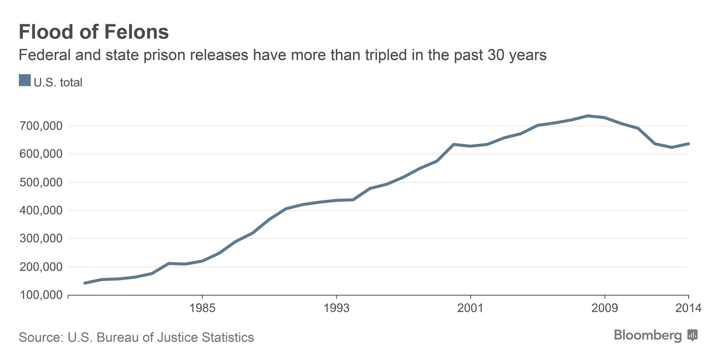

Wolf shares his home with his second wife, his toddler, and a cat he gently picks up every time it scurries into the living room. Nearly half of U.S. children now have at least one parent with a criminal record.

A Corinthians verse, “Love is patient, love is kind, love never fails,” decorates a sofa cushion. Outside his living room window, children gather by a school bus stop as the morning fog lifts in the modest neighborhood of Holiday, Fla.

Less than a 10-minute drive away, he spends his free time volunteering at a Mormon church, where he also gets career training. A workshop book, *The Lord Would Want You to Be Successful*, rests on his living-room’s desk. Men with criminal records now account for about 34 percent of nonworking men aged from 25 and 54 years old, otherwise known as prime working age.

“Myself and many other felons, and we’re facing demons, downtime isn’t a good thing,” he says. Almost half of released inmates are arrested again within eight years, either for new offenses or for violating the conditions of their release. “We’re getting food stamps and cash assistance. We don’t like being on it. But the society that looks down on those receiving assistance is the same society that won’t hire me, and the same society that judges criminals when they reoffend.”

He had the word “forgiven” inked on his forearm after a stint in rehab. On the worst days of his addiction, which started following a car crash more than a decade ago, Wolf remembers taking as many as 40 pills in one day. OxyContin, Percocet, and Vicodin were his usual ones.

“It affected me, seeing guys that have sentences of 20, 30 years. This is a vicious, vicious circle, and we’re not going anywhere.”

**Stymied by Disability, Finding Solace in Art**

By Patricia Laya

The walls of Leroy Moore’s cluttered apartment in Berkeley, Calif., shake with beats of dissent.

Moore, 48, sits at his usual spot in front of the computer on a rainy winter morning, his fingers tapping his cane as he gets lost in a new song by an old favorite, *We The People*, by A Tribe Called Quest. The hip-hop lyrics speak of discrimination.

“Being black, you have to work twice as hard, but being black with a disability, that’s another game entirely,” says Moore, who grew up with cerebral palsy in the suburbs of Hartford, Conn. “I got tiring of hearing I had to prove myself, or that people would have to take a chance on me.”

Moore is just one of almost 9 million Americans who receive disability insurance, a cohort vastly expanded over the past decades by an aging generation of baby boomers, broader eligibility criteria, and intermittent economic downturns. His disability is a neurological disorder that primarily affects his body and muscle coordination and slurs his speech.

Moore studied political science at Southern Connecticut State University. After a couple of back-of-the-shop jobs in college, as a dishwasher and stock clerk, he began a long career in volunteering at centers for the disabled. After moving to the Bay Area in the 1990s, he worked at nonprofits helping people with disabilities lead independent lives. He also began facing his first roadblocks while looking for jobs.

“In one interview, I remember the guy just started to talk to me really slowly. I just went along with it and by the end I told him, ‘You should try speech lessons. They worked for me,’” he says. “He turned bright red and I didn’t get the job.”

“These were so many jobs I knew I was qualified for, like working with disabled youth, and I still didn’t get them.”

Moore started freelancing for magazines, making radio appearances and taking speaking gigs at colleges to make ends meet. His rent-controlled apartment comes to almost $300 a month, wiping out almost half his monthly disability check of around $700.

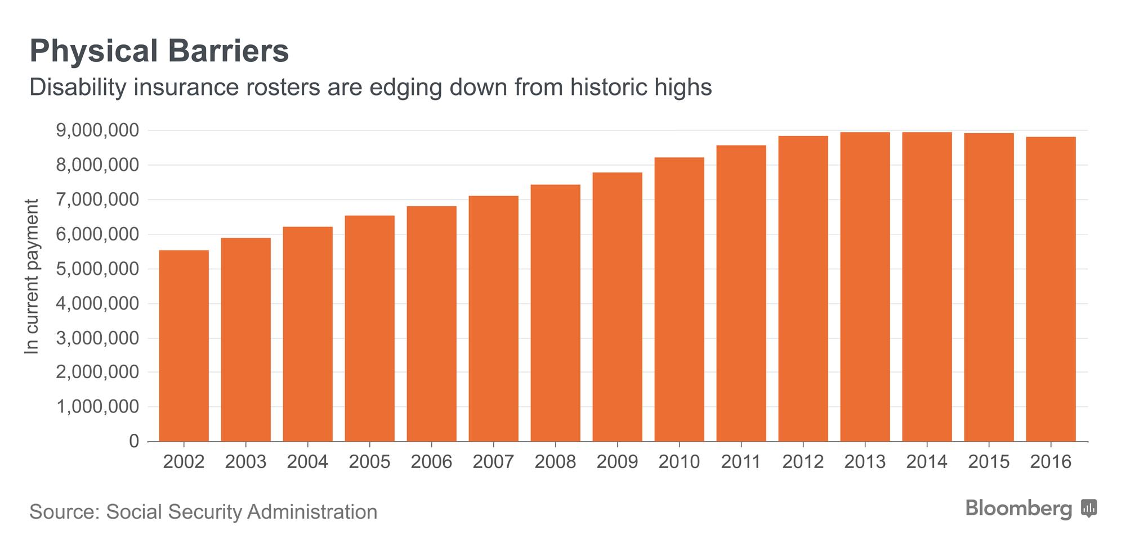

He founded what he calls Krip-Hop Nation, a movement that seeks to unite artists with disabilities and whose work and posters now cover his walls. His favorite records, such as the Cripples’ *What’s in a Name* and books like *Can’t Stop, Won’t Stop: A History of the Hip-Hop Generation*, lie on the floor and against the walls. A figurine of Ray Charles sits atop a television, and a bright blue tricycle he uses to get around town sits in the middle of the living room.

“The hardest part is people’s attitudes—there’s an invisibility surrounding people with disabilities,” he says. “I used to go to the basement and look at my dad’s records when I was a child. That’s where I first saw disabled musicians, especially in blues. It was my mirror.”

**A Drug Epidemic Makes Steel Workers Scarce**

By Jeanna Smialek

At a 200-foot-long steel-rolling machine in Scottdale, Pa., two workers in yellow hard hats monitor screens filled with flashing numbers as they refine rough wire into pencil-thick rod calibrated to a thousandth of a millimeter. This work takes years of training, and MLP Steel Chief Executive Officer Jeff Pfeifer struggles to find employees to fill the job.

Years ago, he spoke on local radio news about the shortage of skilled workers, bringing a line of 100 job seekers to his gravel parking lot.

“Two-thirds of people who came in to interview failed the drug test,” Pfeifer says, shaking his head. The company had to pay to test the applicants, so “it got to be a very expensive radio show.”

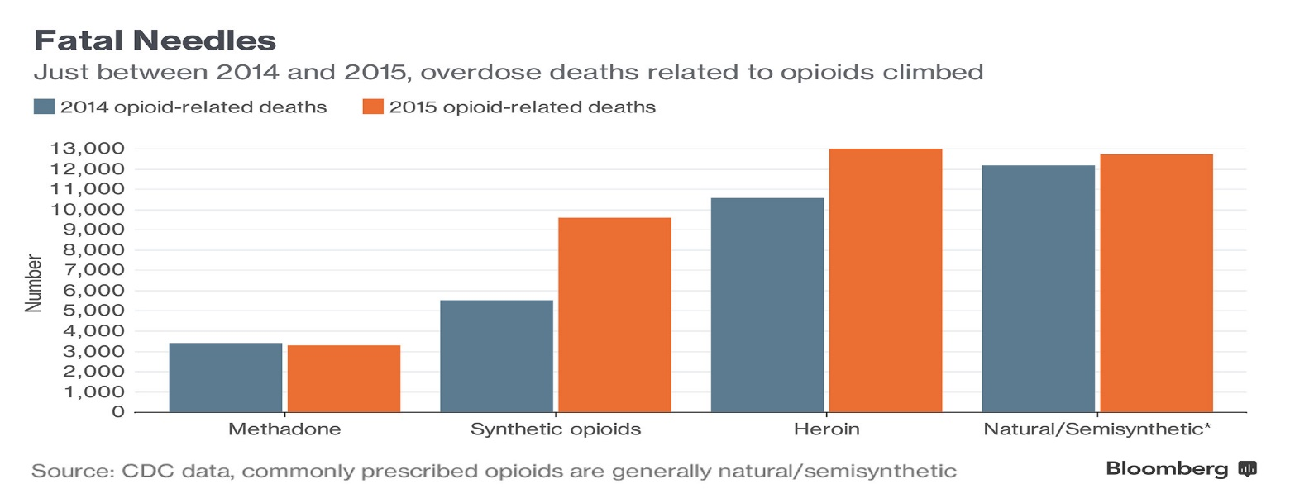

MLP’s business model is built around delivering custom cold-drawn steel, deformed wire and other steel products faster than foreign competitors possibly could. That means workers need to be on top of their game or they dent thin margins and cost precious time.

“We’re not out there with shovels and coal anymore,” Pfeifer says. “We’ll just about hire anybody that we can get our hands on if the person comes in drug-free and they show up for work on time.”

The complicated jobs, which pay $12 to $20 an hour, plus health care and benefits, require sober workers. Sitting in his office behind a wide wooden desk strewn with manila folders and steel samples, Pfeifer explains that his company has a zero tolerance policy: If you’re using drugs, you’re out. “They present a safety problem to everyone,” Pfeifer said. “We need people in here who are good, they’re alert.”

Like much of the Rust Belt, western Pennsylvania is combating an opioid epidemic that’s devolved from painkiller abuse to rampant heroin addiction. “With booze, we could tell it right away; with heroin and whatnot, you can’t,” Pfeifer says.

On the factory floor, a spool of steel wire will be custom-shaped under pressure.

Photographer: William Mebane for Bloomberg

To maintain a sober workplace, MLP pre-screens job candidates and tests workers’ responses in the event of an accident, Pfeifer says. That’s a regular industry practice, and it’s common for candidates to fall short: A Pennsylvania Manufacturers’ Association study from 2014 found that one in three potential hires either refuses or fails the drug test.

“We’re down to a core group of workers right now,” Pfeifer says. The labor shortage comes primarily because older steel workers are retiring and younger generations attach a stigma to steel, he thinks, but drugs are exacerbating the shortfall.

Pfeifer’s company is managing its labor shortage by substituting machines for workers. He walked me through one of the motor grease-scented blue warehouses in Scottdale, gesturing toward a computerized panel on the plant’s newer mill and explaining that it stands in for a human worker. It monitors steel as it passes through rollers and dips in and out of water-filled cooling tanks, communicating with a central, manned station down the line.

Eventually he’s going to need a specialist to maintain even this machine. And the hiring problem rears its head anew.

**At 55, a ‘Rainy Day’ Turns Into a Year**

By Jeanna Smialek

Mike Schlager has gotten plenty of practice at job interviews over the past 15 months.

The 55-year-old from Buffalo lost his job as a lumber-company information systems manager a year ago. He was the highest-paid person in his department when it underwent a management change, so the dismissal didn’t come as a complete surprise. In fact, he’d started looking into new jobs months before he was axed.

Still, he was unprepared for what came next: more than a year of fruitless running on the hiring treadmill. Schlager estimates that he’s applied to 70 or 80 positions. A dozen companies called him back repeatedly. Whenever management or the human-resources department realizes he’s in his 50s, the offer disappears.

“The first thing they say is, ‘Boy, you have a strong resume. We’d love to talk to you,’” says Schlager, who lives alone and has a grown daughter. “Then they bring you in for a one-on-one interview and they see that you aren’t 25, that you’re an older person.”

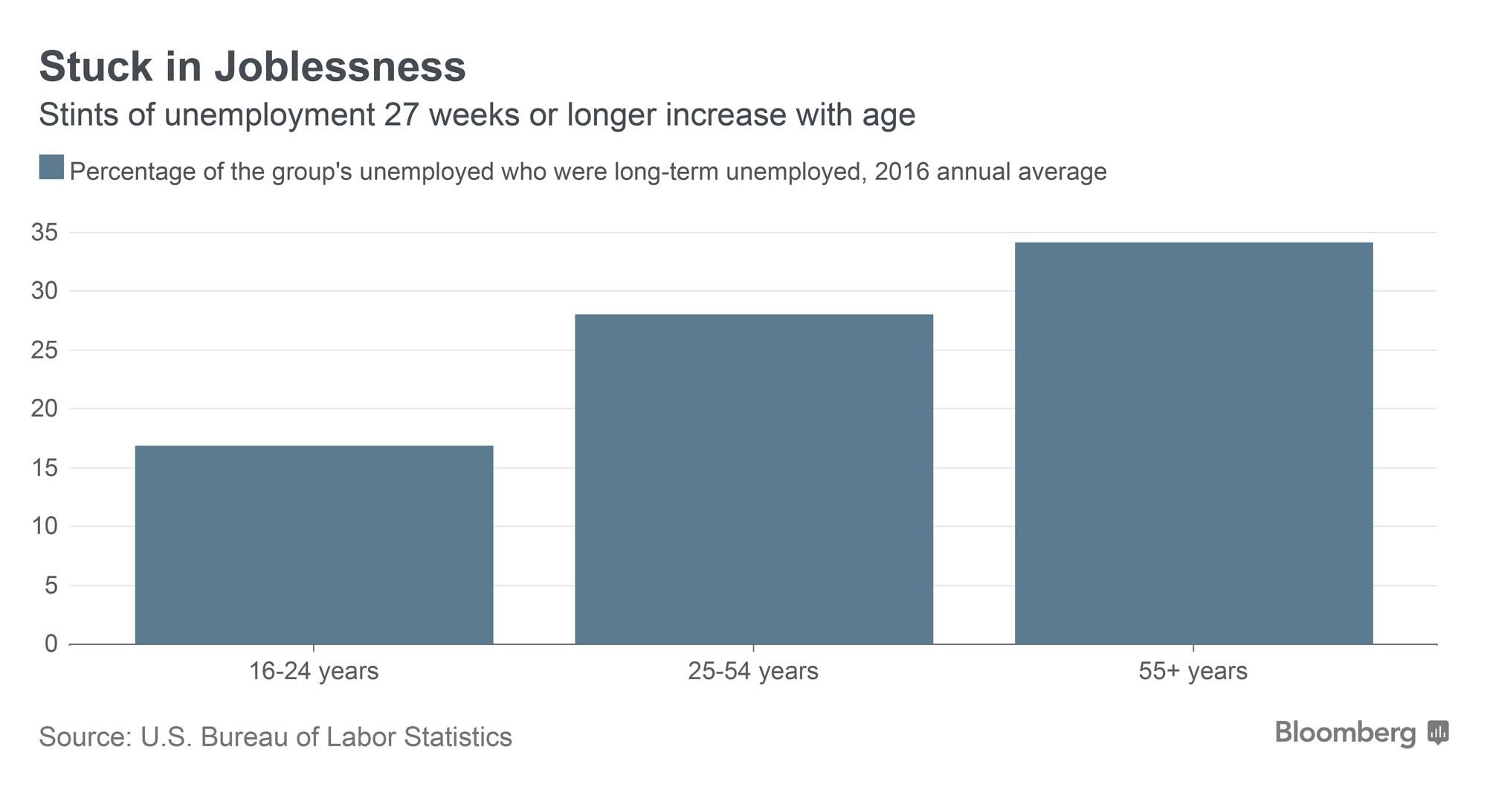

By Schlager’s reckoning, employers probably don’t want to hire someone who will be a health-care expense and who might retire soon, even though he has 37 years of experience. The idea that age discrimination is a barrier to hiring is supported by economic research, and it could be increasingly important as more and more Americans cross the older-than-55 threshold.

“It’s a common theme,” Schlager says. “I talk to other people in my neighborhood around my age, and this happens all the time.”

Schlager has worked at big-name companies, including FedEx Corp., and his résumé is filled with programming, hardware, and operating-system skills. He says the fact that he gets so far into the interviewing process proves that his abilities aren’t the problem.

Anita Wolniewicz, program director at Support Services Corporation, discusses Mike’s employment situation.

Photographer: William Mebane for Bloomberg

“It’s very discriminatory, if you ask me,” Schlager said, explaining that interviewers avoid asking his age or mentioning it, because such discrimination is illegal. He has nothing on his resume that marks his age. “It’s a vicious game, and they do it legally, but there’s that undertow.”

Schlager was making $53 an hour working 35 to 40 hours a week in his last position, but he’s applying to lower-skill, lower-pay positions in logistics as he broadens his job search. There’s a limit as to how far down the ladder he’ll drop, though, because he wants to make sure that he has employer-provided health-care coverage.

Not finding employment isn’t an option. While he has relatively low living expenses, Schlager is dipping into his 401(k), so he’ll need to replace what he’s withdrawn. And, beyond financial motivation, he wants a job for its own sake.

“It just kills me to sit here, and not work, and have the abilities that I do,” he said. “I call it a rainy day that turned into a rainy month that turned into a rainy year.”